Title A re-assessment of Dr Robert Knox and his contribution to early evolution science
Shortened title Knox and evolution.
Main text 5003 words
Abstract 149 words
Authors Ken Donaldson BSc, PhD, DSc, FRSB, FFOM, FRCPath, Senior Research Fellow, Surgeons Hall Museums, Edinburgh and Professor Emeritus, University of Edinburgh.
Christopher Henry MA, Director of Heritage, Surgeons Hall Museums, Edinburgh.
Corresponding author’s contact details
Professor Ken Donaldson
Senior Research
Fellow Surgeons' Hall Museums
Royal College of Surgeons of Edinburgh
Nicolson Street
Edinburgh
UK
EH8 9DW
Telephone 07445572038
Email kdctoxtwo@outlook.com (Home)
Financial and Competing interests None
Keywords Robert Knox; Transcendental Anatomy, Geoffroy, Unity of plan, evolution
Abbreviations
TA Transcendental Anatomy
TAists Transcendental anatomists

Abstract
Dr Robert Knox was publicly scorned and disgraced for his unwitting involvement in the Burke and Hare serial murders in 1828. However, he was also a brilliant anatomist and espoused the European movement in Transcendental Anatomy (TA) which aimed to uncover the laws governing what we now know as the origin of species and evolution. Knox fully embraced TA during a sojourn in Paris and taught it on his return to Edinburgh, where there was a critical mass of like-minded TAists. Charles Darwin spent 1825-1827 as a medical student in Edinburgh when TA was at its peak amongst the city’s anatomists, and evolution – then known as transmutation- was a source of interest and controversy. Knox intended researching into TA but this was thwarted by conflicting demands on his time in the second half of the 1820s decade. He did, however, go on to champion Transcendental Anatomy and write extensively on it.
Dr Robert Knox
Dr Robert Knox (1791-1862) the Edinburgh anatomist, was the first Conservator of the Museum of the Royal College of Surgeons of Edinburgh. His name remains in currency today largely because of the enduring interest shown in the tragic story of the West Port Murders in Edinburgh in 1828, involving the serial killers Burke and Hare. Knox was extensively vilified for buying 16 bodies from Burke and Hare’s endeavours, for dissection in his anatomy school. To this day those only casually acquainted with the Burke and Hare narrative view him as, in some way, complicit in these murders. In fact. Knox had no part in the West Port murders and his staff were unaware that they were receiving bodies from murderers. Exoneration in this regard came from Burke himself, in his confession just prior to hanging and from a committee of senior figures in Edinburgh Medicine and Law, who examined the evidence [1].
The current one-dimensional view of Robert Knox, almost universally held, derives largely from the salacious and misleading representations of Knox ever since. Literature and popular culture abound with books, films, musicals etc. about Burke and Hare, or thinly veiled ‘fictional’ re-tellings of the West Port Murders story. [2] These have unfailingly served to promulgate an image of Robert Knox that, whilst often hinting that he was a medical visionary, stress his supposed darker characteristics such as conceit, callousness, cruelty and even madness. These portrayals of Knox are grotesque caricatures of a true post-enlightenment figure who, although flawed, was a well-read and cultured man, a brilliant anatomist, musician (violin), conversationalist and polyglot, who was reaching the zenith of his profession when the West Port Murders brought this stellar career to an ignominious halt.[1] This paper is confined to Knox’s contribution to anatomical science through his espousal of Transcendental Anatomy.
Transcendental Anatomy and anatomy in the early 19th Century
Knox was dedicated to the pursuit of Transcendental Anatomy (TA) and this needs to be understood in the context of the nomenclature of the time.
- Topographical anatomy was (and still is) the type of anatomy taught to medical students and addresses the relationship of the structures of the human body, such as organs and tissues, to each other, and their function.
- Pathological anatomy embodied the concept that diseases arose in specific organs and tissues and by the early 19th century it was replacing the old and totally wrong-headed humoral theory of the origins of disease.
- Transcendental anatomy.
Transcendental Anatomy (TA) contrasted sharply with the medical context of these first two. TA aimed to elucidate the relationship of animal types to each other and to past forms, as seen in the fossil record, i.e. it addressed what we now know as evolution and the origin of species. TA was a part of the larger Philosophical Naturalism movement, which sought to uncover the laws at work throughout the entire natural world and was the forerunner of that branch of science now known as Natural Science. [3]. The focus of TA was the ‘how’ and ‘why’ of animal structure but in a radical approach its adherents transcended mere description and classification, the standard approaches up to that point The transcendental aspect of TA lay in its contrast to the empirical, inductive approach to enquiry which had emerged from the enlightenment. Instead, TA was rooted in Romanticism and Idealistic philosophy which led the TAists to claim a profound intuition into the natural world. This, they claimed, inspired them to transcend mere sensory and observational aspects of nature and reach the highest level of understanding and insight which they believed would bring them the explanations and eventually quantitative laws that would illuminate the origins and maintenance of animal types.
TA was therefore at the cutting edge of anatomy and zoology at that time and attracted the brightest and best of the academic zoologists and comparative anatomists. TA was also a matter of controversy since it presented a materialist alternative to the biblical creation account of the origins of the various species on earth. However, the post-enlightenment decline in religious authority was more permissive and, in any case, this was not a new controversy. There was a long and rich history of thinking arguing for a process of change of one species into another. [4] In fact Darwin’s preface to the 6th edition of the ‘Origin of Species’, [5] lists at least 30 writers who, predominantly in the first half of the 19th century, had addressed evolution and the origin of species prior to the first publication of Darwin’s book.
By the early 19th Century the terms transmutation and transformism were commonly used by the TAists and others, to describe what we now know as evolution of one species into another. (4) The term evolution itself was not used in its modern biological context until after the geologist Charles Lyell (1797 –1875) used it in 1830 in the context of geological change.
TA was a subject of study entirely of its time – the late 18th and early 19th century - the time before Darwinism, and the neo-Darwinian synthesis provided natural selection, chromosomes, genes, DNA etc. as the explanation the TAists sought. So, TA does not exist today, except as a topic of historical interest. TA was also a movement of place, the main places being Germany where it began, with Johann Wolfgang von Goethe (1749 – 1832) and Lorenz Oken (1779 – 1851) and then Paris, where it was championed by Étienne Geoffroy Saint-Hilaire (1772 – 1844; known as Geoffroy) and then, of special interest here, Edinburgh.
Knox and TA in Edinburgh
Like many ambitious Edinburgh doctors, Knox spent a year in Paris carrying out autopsies and learning the new discipline of Anatomical Pathology and he taught Topographical Anatomy to his students. However, his greatest passion was for TA, as he declared -
‘the study of comparative anatomy, embryology, and the transcendental, was from my earliest years the favourite and engrossing object of all my private studies,’ [6]
TA had emerged to an extent in Edinburgh before Knox went to Paris, with Knox’s mentor and friend John Barclay, whose school Knox eventually took over. Barclay was a keen comparative anatomist, familiar with the transcendental approach [3]. However, Barclay’s pre-anatomical career as a Minister in the Church of Scotland, [7] no doubt provided a conflict with the materialistic TA arguments for the origin of species. Other Transcendental Anatomists (TAists) in Edinburgh at that time included Robert Grant (1793 –1874), the Edinburgh zoologist who, like Knox, had fallen under the influence of Geoffroy whilst in Paris [3]: the naturalist Edward Forbes (1815 –1854) and Edinburgh anatomy lecturer John Fletcher (1892-1936). [7,8]
TA reached its peak in Edinburgh between 1820 and 1830, bracketing the years that Darwin spent studying medicine there (1825-1827) and he was very likely influenced by it. It was championed by Robert Knox and a few others and then fell out of favour to be superseded in the Darwinian revolution. [8] As Rupke observed, with reference to a list of leading UK TAists that contains Knox and other Edinburgh figures:-
‘these figures all sought to reform the biomedical sciences by borrowing the Romantic, or transcendental, program from continental sources…Significantly …these figures were not Oxbridge educated but shared an Edinburgh background’. [9]
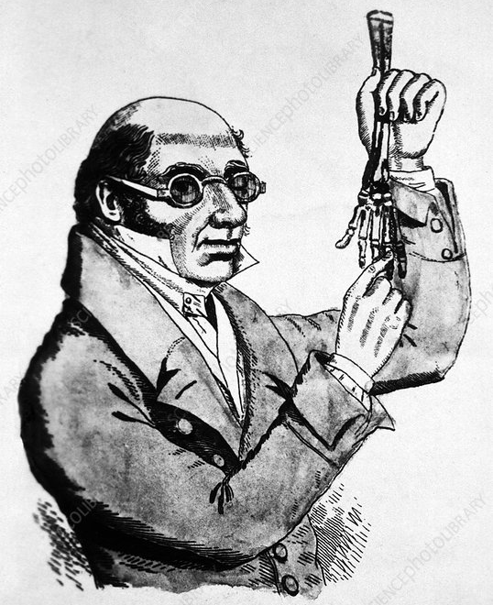
Figure 1 Dr Robert Knox. Courtesy of Wikipedia Commons)
Tenets of TA
Knox himself wrote about how difficult it was to pin down the aims and doctrine of TA (see later) and Rebock refers to -
‘’The vogue of transcendental anatomy, one of the most curious- and for the historian one of the most elusive -episodes in nineteenth century biology,’ [10]
However, it had some basic tenets and putative ‘laws’ which were studied and pursued by its adherents.
1) Law of Unity of plan
The most obvious feature offering the idea that animal species arose from other animal species by modification, was the striking similarities in the visible anatomy between different species. This idea of a single body plan, modified in different species, was one of the earliest, being advanced by Goethe and Oken at the dawn of the movement. It became enshrined in the central law of TA, ‘Unity of plan’ (also called Unity of composition/ Unity of structure/ Unity of organisation). [10] This postulated one ideal, primary plan, or ‘archetype’, on which all vertebrates and in some versions even invertebrates, were based. The TAists believed that Unity of plan operated in the embryo according to laws that could be revealed by research. Additionally, the plainly seen diversity in animal structure around the archetype meant that there must also be laws governing systematic departures from the plan and so they sought to understand these laws in order to explain diversity. [3] Most importantly, Unity of plan was taken to be persuasive evidence of common ancestry and therefore of transmutation of one species into another.
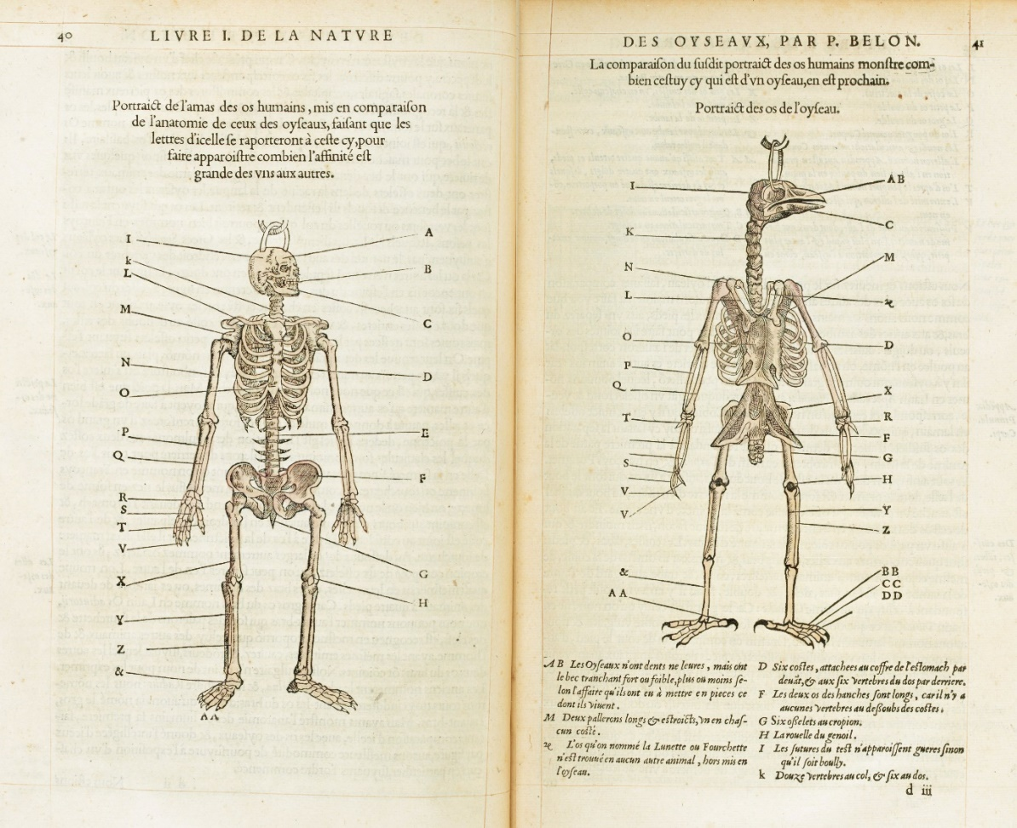

Figure 2 Skeletons of man and bird side by side, for comparison, showing many homologies. From Pierre Belon 1555 [11] Wikipedia Commons
If bones or organs were inherited from common ancestors it would be anticipated that they would be similar in appearance, although they might differ to various extents, and that they would carry out the same function. Such paired structures in different animal species are referred to as homologues. A typical example of homology is the pentadactyl (5 finger) structure of the tetrapod limb, which is seen from humans to bats, to fish, to crocodiles. This idea had been around for centuries, a good example being Pierre Belon’s (1517–1564) 17th century diagram highlighting the similarities in skeletal structure between birds and humans. (Figure 2) By the 19th century the TAists had identified multiple homologies and in fact Richard Owen (1804 –1892), possibly the leading exponent of TA in the UK and who is normally credited with the formal definitions of homology, referred to TA as ‘homological anatomy’. [3]

2) Law of serial homology of parts
Homology, as described above is bound to accompany Unity of Plan/common descent and was more specifically named ‘General homology’ by Richard Owen to differentiate it from ‘Serial homology’. The latter differs by being homology ‘within species’, not ‘between species’ and is characterised by repetition of a basic or archetypal structure, with modification, within the body of an animal. The most widely cited example of serial homology, showing repetitive structures in the same individual organism with subtle differences, is the vertebrae of the spinal column. The vertebrae change structure subtly, then considerably, in going from one end of the vertebral column to the other, but they are identifiably similar. The distinct impression is gained that the different forms of vertebrae are variations on a basic structure and this appearance is clearly at odds with the idea that each vertebral type originated without reference to the rest. Another example is the arms and legs in tetrapods, which are so similar they must derive from serial homology. Finding such homologies was a major aim of the TAists, as it fuelled their argument that there was continuity of descent with change. One of the most celebrated and widely disputed examples of serial homology claimed by Goethe and others was that the bones of the skull were modified homologues of vertebrae. In fact, one school of TAists asserted an extreme form of serial homology by suggesting that all the bones of the human skeleton were simply modified homologues of vertebrae! [12]

3) Law of Recapitulation
This law, based on embryology, proposed that commonality of descent was discernible in the way that embryos of higher animals passed through, or recapitulated, stages that resembled the adult forms of lower vertebrates. This was considered to reveal the animal’s evolutionary history, hence the shorthand term – ‘ontogeny recapitulates phylogeny’ (or embryology recapitulates evolution). Eventually Geoffroy extended this to the suggestion that vertebrate embryos even passed through stages representative of invertebrates, like cephalopods and insects. [10] The law of recapitulation was first formulated by the German anatomist Johann Friedrich Meckel (1781–1833) and the embryologist Antoine Étienne Renaud Augustin Serres (1786–1868) and is also known as the "Meckel-Serres Law". Meckel published an essay [13,translated in 14] in which he provided the example that during early heart development in a mammal, there is first a tubular stage like an insect’s heart, then a single chamber develops like a crustacean’s heart, then both a ventricle and auricle arise as in a fish heart and then the auricle divides into a 3 chambered heart which resembles the heart of an amphibian. Similar evidence, this time in mammalian brain development, was reported by Serres. [15, translated in 14,]
The TAists identified a changing environment as a key force that acted to produce variation around the Unity of plan by altering embryonic progression through these various stages i.e. ‘arrested development’. Geoffroy investigated this with a very modern, empirical approach by changing the developmental environment of chick embryos by shaking the eggs, heating them, or limiting the oxygen supply through the shell. This gave rise to deformed ‘monsters’ which Geoffroy claimed to be new species resulting from arrested developments caused by the changed developmental environment. [8] Carrying this argument into mammals, an effect of the environment on a mammalian embryo might be expressed as arrested development at, say, the reptilian stage. This would be revealed as a child being born as a ‘monster’, with some characteristics that could be interpreted as reptilian. It was suggested that such characteristics would occasionally be passed on to subsequent generations producing new species.
Knox himself did not like the concept of arrested development and preferred the term ‘persistence of embryonic forms into the adult’ as he came to believe that this was a normal and vital part of species change/evolution. As described in more detail later, Knox believed that the embryo of any animal contained the ‘plan’ for all the species in its genus and had the potential to give rise to an adult of any of the species in that genus. [6] He conjectured that the actual species into which that embryo developed was determined by the developmental environment during embryogenesis. [6] Half a century after Meckel and Serres, Ernst Haeckel attempted to reintroduce a form of the Meckel and Serres Law as his ‘Biogenetic Law’ and in so doing he produced his famous embryo illustrations which demonstrate the argument. [16] It is important to say that there has been dispute over the veracity of Haeckel’s claim. [17, 18] Modern biologists have shown that the resemblance in embryonic forms seen across the animal kingdom is purely superficial and recapitulation theory has fallen out of favour. Although now discredited the idea was influential at the time [17,18] and most authorities, including the TAists, believed that ‘Ontogeny recapitulates phylogeny’ and was evidence for transmutation.
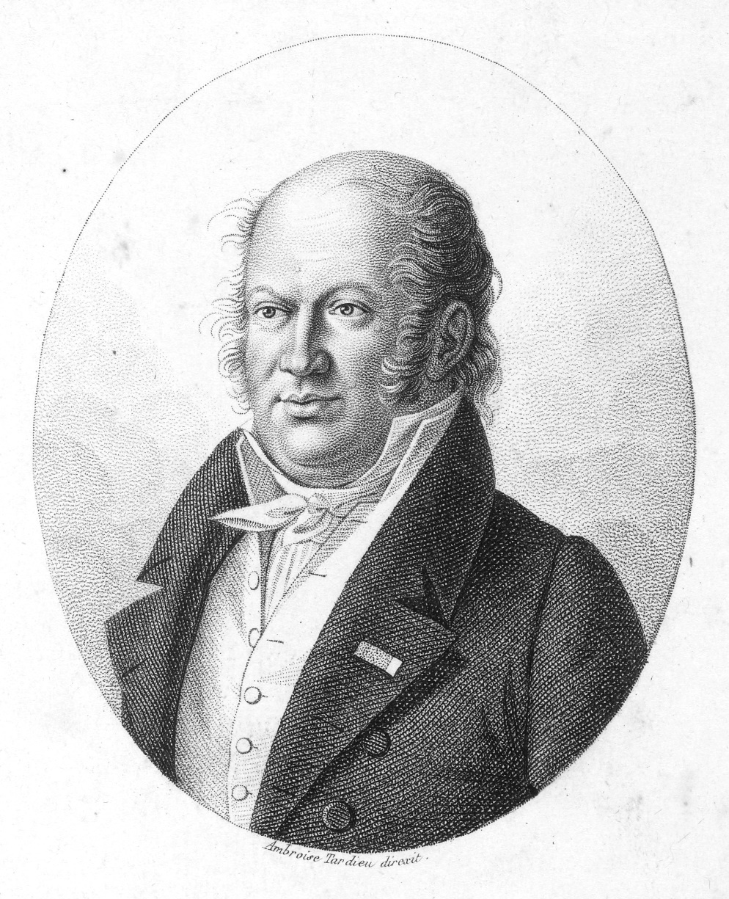

Figure 3 The French naturalist Étienne Geoffroy Saint-Hilaire’ (Geoffroy) who established the principle of "Unity of Plan" and who met Knox in Paris and influenced him greatly towards the pursuit of TA. (Courtesy of Wikipedia Public Domain)

4) Transmutation
Transmutation was the 19th C term used to describe the evolution of one species to another and this continuity of descent was fundamental to Unity of plan, their defining concept. A common misunderstanding is that Darwin ‘discovered’ evolution, first writing about it in ‘The Origin of Species’’. In fact, there was widespread discussion and writing on transmutation between species centuries before Darwin, [4] but no serviceable mechanism had been advanced. Darwin’s triumph was the discovery of the mechanism of evolution i.e. Natural Selection, and his presentation of a huge amount of accumulated and persuasive evidence in support of that mechanism in his book. Transmutation was widely discussed and accepted by the TAists and many others, long before that. [4] In 1850, nine years before the first publication of ‘The Origin of Species’, Knox wrote that: -
‘the simple animals of the early world may have produced by continuous generation the more complex animals of the after ages; that the fish of the early world may have produced reptiles, then again birds and quadrupeds: lastly man himself?’ [19] (author’s underline)

TA in Paris
The dominant TAist in Paris was Geoffroy (Figure 3) but he was at odds with the major power in French Comparative anatomy, Georges Cuvier, more formally Jean Léopold Nicolas Frédéric, Baron Cuvier (1769 –1832). Cuvier had founded the disciplines of comparative anatomy and vertebrate palaeontology and was adamantly not a TAist. Cuvier’s view of the origin of species over time involved cyclical catastrophes (floods) and creations. Created anew by a God following each catastrophe, Cuvier saw fossil animals in any geological stratum as being perfectly fitted and having no particular relationship with extant animals’ or even animals of an adjacent stratum. [6,20] Cuvier argued teleologically, from creationism, that anatomical structures fitted each animal’s environment. For example, he argued that fish had organs and structures designed and created by a God that suited them to the aqueous environment. He believed that the static nature of the environment between catastrophes, meant that species did not change and had been the same since their creation. This is diametrically opposed to Geoffroy’s TA which was based around continuity of descent and species change in response to a slowly changing earth environment, without catastrophes, over a protracted period of time according to the uniformitarian claim and in response to the functional needs of the animal. [6,7] Eventually Cuvier and Geoffrey had a debate to try and settle their differences [7] but despite two months of increasingly acrimonious argument in the French Academy, no clear winner emerged. Knox acknowledged Cuvier’s powers as the ’descriptive anatomist par excellence’ but rejected his catastrophism and Cuvier’s assumption that there was ‘absolute fixity of species’. [20]

Knox and TA
As described above, during his one-year sojourn in Paris (1821-22) Knox was greatly influenced by Geoffroy, because of his transcendental approach and his zeal for ‘Unity of plan’, which Knox enthusiastically embraced. By the time of his return from Paris at the start of the 1820s, Knox was so firmly wedded to the transcendental approach to anatomy that -
‘Knox discussed transcendentalism in his lectures of the 1820s and 1830s … the first in Britain to do so.’ [3]
In one of his books, [21] Knox incorporated a section called ‘Doctrine’ which shows his personal vision of the TA creed, its complexity and ambiguity. He commences with a claim to authority, in that ‘strict’ scientific thinking (i.e. induction), would not measure up to the intellectual challenge of the transcendent. -
‘The doctrine taught by transcendental anatomists of Germany cannot be formuled in so clear a manner as strict science demands. Nevertheless, it may be made perfectly intelligible to those competent to generalize their ideas and to reason abstractedly on science’.[21]
and
‘To the mind occupied with individual facts, disjointed details, or observations mechanically grouped together, the doctrine of unity of organization, and of all the mighty results it leads to, will forever remain a mystery.’
Then he gives examples of homologous structures that are found across vertebrates of very different degrees of complexity that, he claims, are always present. However, even if these structures are not apparently present, in unabashed special pleading, Knox claims that -
‘..even although such vestiges could not be found in all cases, it was not unreasonable to conjecture that such existed, either microscopically, or under some unrecognizable form’
Finally, the special pleading approaches fever pitch -
’The plan of unity does not require that all the material germs of the organs be the same in all animals; it is sufficient that the plan seems one.’ (author’s underline)
Knox then addresses the other major pillar of the TA, the argument from embryological recapitulation. He states that
’it was discovered that they (human embryos) resemble normal, or persistent forms of animals lower in the scale; that the embryo of man for example has at first both gills and lungs,’
Finally, he affirms the recapitulation claim -
‘the human embryo shadows forth in the history of its growth, from conception to birth the history of all the forms that live; lastly of all that ever lived from the first appearance of life upon the globe.’. [21]

Knox was not a believer in the standard view of evolutionary descent operating at the species level, believing instead that there had been one creation, not of species but of genera. His extraordinary view of the centrality of genus was that all the possible species in that genus were potentially present in an embryo. The embryo was thus a reservoir that had the potential to become an adult of any of the species within that genus. Knox used the salmon, a particular interest of his, as an exemplar
‘The embryo of the young of any species of the Salmonidas, for example, includes in its internal structure, and external coloration and robe, the characteristics of all the species of all the genera which exist, or probably ever existed; so that it depends merely on circumstances clearly physical and external which species is to appear first, which last, in the zoological history of the world.’ [22]
So, although individual species may become extinct ‘the plan’ continues forward in the embryo at the genus level, enabling any species in the genus to be tested in the environment. To become the adult species from this ‘genus pool’, the environment had to act on the embryo to produce differential persistence of the embryonic features required.
‘To institute a species all that is required is to omit or cause to disappear, or cease to grow, some parts of the organ or apparatus already existing in the generic being (the embryo)’. [23]
Although Knox believed in transmutation and evolution, he did not assign progress or purpose to it and in keeping with his anti-religious views [1], he certainly did not accept that man was the highest achievement of nature, instead hoping that --
‘..the boast about the higher characters of the present organic races will be abandoned, and the law of development and progress simply stated as it is, without a reference to successive improvement; for successive improvement implies a final purpose.’ …. [19]
Amusingly, he cites fish in support of this argument -
‘…the world, for countless thousands of years, was inhabited only by fishes; could they have spoken, and left us records, we should have found, no doubt, that they considered themselves as the most perfect of all Nature's works, and the beings for whom the seas, at least, if not the dry land, had been made.’ [24]

Research in TA
Rehbock has described the nature of the research that TAists undertook to discover the laws underlying the Unity of plan etc. As Knox implied above, it did not generally involve the inductive (Rehbock calls it ‘Baconian’) method that dominates modern scientific practice-
‘The method proper to this search for patterns of the living realm was not always limited to Baconian mode of inducing generalizations from facts previously amassed. In this instance philosophical was synonymous with transcendental, implying that patterns to be discovered in nature might best be acquired by intuitive leaps of the imagination, rather than coaxing from impersonal heaps of data’. [3]
In order for the transcendental anatomist to make leaps of intuition he needed, as required by the Romantic creed, to be ‘deeply and delicately sensitive’ (3) to the natural phenomena he was studying.
In 1852, only 10 years before his death and 30 or so years since he first adopted TA from Geoffroy in Paris, Knox describes what was still not known about TA and therefore must form the basis of research-
‘We know not the causes of the specific and generic difference in animals, nor why such differences continue fixed for a period… they depend on secondary laws which some future Newton may discover; ‘…’the greatest of discoveries remain to be made – why varieties of living animals ..’.have constantly decorated the earth’. [21]

This suggests that in the 30 or so years that TA had been at the centre of his thinking and of others, little progress had been made in elucidating the laws and mechanisms at work in the origin of species and with hindsight it is easy to see why. Seeking the laws relating to the animal ‘plan’ without knowledge of the laws of genetics, which would not even begin to emerge for at least another half century, amounted to thrashing around in the dark (see later).
Knox’s pursuit of TA research
Knox returned to Edinburgh from Paris in 1822, where he had seen that, by teaching topographical anatomy, the French TAists could fund their research in TA. Topographical anatomy was a topic gaining in importance in medical teaching with the rise of anatomical pathology and the waning of belief in the humoral theory of disease and the rise of surgery. Knox realised that his knowledge as a topographical anatomist could be put to service to pay for research into TA, his real interest, but he also needed a museum to carry out the research. In a letter to the Royal College of Surgeons of Edinburgh (RCSEd) in 1824, he offered his services as Conservator of their museum; given his considerable and growing reputation in anatomy, they quickly snapped up Knox’s offer. He took care to note that he would only take over the conservatorship under the condition that he would have lifetime access to an anatomical museum to carry out his own research:-
‘I am moreover willing that the museum so erected should be considered as the property of the College and intended for the use of its Fellows (as is at present their pathological collection) reserving to myself during my life time the use of the museum for the furtherance of my favourite pursuits and studies’. [25]
Knox took up the post as first Conservator of the RCSEd museum in 1826 and held the post until 1831. As regards harnessing the money-generating power of topographical anatomy, Knox began in 1825, to share the running of the Barclay School, with its huge and lucrative student numbers; he took over as Head of the school the following year on Barclay’s death.
Initially, on his return from Paris in 1821, Knox had embarked on a broad programme of comparative anatomy research using facilities borrowed from Professor Robert Jameson in the University of Edinburgh College Museum [8]. However, by 1826 he had achieved a situation whereby income from the Barclay School, plus access to museum premises from RCSEd, would together enable him to fund TA research in his own museum. Theoretically, at least, Knox could now proceed to research TA, but this was not to be. In fact, his research slowed dramatically in the second half of the 1820s decade, most likely as the arduous administrative and teaching implications of his plan began to emerge and impact -
- From 1825 onwards Knox’s employment as Conservator of the Surgeons’ Museum imposed a large administrative burden of specimen collection, preparation and cataloguing. This had been increased greatly by the purchase, transport and cataloguing of over 3,000 specimens from Dr Charles Bell’s Windmill Street Museum in London, in 1825.
- From 1826 onwards, following Barclays retiral, Knox’s takeover of the running of the Barclay school with its 500 pupils, placed on him a broad and arduous teaching and administrative commitment.
- From October 1828 Knox was overwhelmed by the disaster of the involvement of his school in the West Port murders.
This initial burst of activity, followed by stasis in the second half of that decade, is reflected in the marked decrease in his research output in the second half of the decade compared to the first half. Between 1822 and 1824 Knox read 12 papers to the Edinburgh Wernerian Society [26] on research in beaver, cassowary, the comparative anatomy of human races based on skulls etc.; in the same period, he published 7 papers in various learned journals. [27] However, in the next 5 years’ 1925-30, the period of intense teaching and administrative activity and the Burke and Hare affair mentioned above, he read only 2 papers to the Wernerian Society and published a single paper in a learned journal. By 1831, in the wake of the West Post murders scandal, Knox had been eased out of his position as Museum Conservator by the Royal College of Surgeons of Edinburgh and within a few years student numbers in his school began to decline. He was never again in a position where he had sufficient funds, or had a museum, such that he could carry out TA research. Thus, unfortunately, as Rupke puts it, Knox
‘..advanced the doctrine of transcendentalism through fervent preaching rather than original research.’. [9]

The laws underlying Unity of plan finally revealed
Even if he had been able to conduct TA research, the resolution of the mystery of Unity of plan etc. lay well into the future. By 1859 Charles Darwin published ‘On the origin of species by natural selection’ which, along the neo-Darwinian synthesis eventually revealed the nature of the genome and its related biology. These advances relied on a century of intense development in microscopy, cell biology, biochemistry, molecular genetics, X-ray crystallography etc, which were beyond the imagination of the TAists. These discoveries inevitably moved the understanding of the ‘plan’ by which animals were reproduced and evolved, away from the descriptive comparative anatomy practiced by the TAists, towards reductionist molecular genetics. They culminated in the discovery of the structure of DNA by Frances Crick (1916 –2004) and James Watson (born 1928) in 1953, then elucidation of the genetic code, gene expression, etc. (28,29]
None of this was available to TAists like Robert Knox in the early 19th Century, who sought to understand how animals were the way they were, how Unity of plan arose, or how new species occurred. Nonetheless the rise of TA and its theories presaged the Darwinian revolution and Darwin, who attended Edinburgh University Medical School 1825-1827, likely attended some of Knox’s lectures. [27] Certainly, in Edinburgh’s many learned societies like the Plinian and Wernerian, Darwin mixed with others espousing the TA doctrine. [8] There, in the company of Robert Knox and other TAists, he must have been exposed to transcendentalism which likely influenced his future thinking about speciation eventually crystallising out in ‘The origin of species by means of natural selection’.

References

      - Donaldson K, Henry C. Dr Robert Knox and his book on fishing in Scotland: A window into his mind. J R Coll Physicians Edinb. 2022; 52: 159-165.
      - McCracken-Flesher C. The Doctor Dissected: A Cultural Autopsy of the Burke and Hare Murders Oxford: Oxford University Press; 2012
      - Rehbock PF. Philosophical Naturalists. Themes in Early Nineteenth Century British Biology. University of Wisconsin Press: 281pp; 1983.
      - Stott R. Darwin's Ghosts: In Search of the First Evolutionists.: London Bloomsbury Publishing; 2013
      - Darwin, C. R. The origin of species by means of natural selection, or the preservation of favoured races in the struggle for life. 6th edition; with additions and corrections.: London John Murray; 1872
      - Knox R. Xavier Bichat: his life and labours.: A Biographical and Philosophical Study. The Lancet, 1854 : 64; 393-396.
      - Desmond A. The politics of evolution. Chicago: University of Chicago Press; 1989.
      - Jenkins W. Evolution Before Darwin: Theories of the Transmutation of Species in Edinburgh, 1804-1834. Edinburgh: Edinburgh University Press; 2021
      - Rupke, NA. Richard Owen: Biology without Darwin: Chicago: University of Chicago Press; 2009
      - Rebock P.F. Transcendental anatomy in Cunningham A. and Jardine N. Eds. Chapter 10. Romanticism and the Sciences: Cambridge University Press; 1990.
      - Belon P. 1855 L'Histoire de la nature des oyseaux, avec leurs descriptions, & naïfs portraicts retirez du naturel : escrite en sept livres, Paris: Corrozet G; 1555.
      - Green JH. Vital dynamics; the Hunterian oration before the Royal College of Surgeons in London, 14th February 1840 London: Pickering; 1840
      - Meckel, JF. Entwurf einer Darstellung der zwischen dem Embryozustande der höheren Tiere und dem permanenten der niederen stattfindenen Parallele: Beyträge zur vergleichenden Anatomie, vol. 2.: Leipzig Reclam; 1811
      - Gould SJ. Ontogeny and phylogeny. Harvard: Bellknap Press; 1977
      - Serres ERA. Pricipes d’embryogenie de zoogenie et de teratogenie. Mem. Acad. Sci. 1834: 25; 1-943.
      - Haeckel E. Anthropogenie oder Entwickelungsgeschichte des Menschen. Leipzig: Engelmann; 1874
      - Pennisi E. Haeckel's embryos: fraud rediscovered. Science. 1997 :277; 1435.
      - Richards R. Haeckel's embryos: Fraud not proven. Biology & Philosophy: 24;147-154.
      - Knox R, The Races of Men: A Fragment. Philadelphia: Lea and Blanchard; 1850.
      - Knox, R. On the Application of the Anatomical Method to the Discrimination of Species. The Anthropological Review 1863: 1; 263-270
      - Knox R. Great Artists and Great Anatomists: A Biographical and Philosophical Study. London: John van Voorst; 1852
      - Knox R. Contributions to the philosophy of zoology with special reference to the natural history of man. The Lancet 1855:21; 45-46;
      - Knox R. Introduction to Inquiries into the Philosophy of Zoology. The Lancet 1855 :65; 625-627.
      - Knox R. Inquiries into the philosophy of zoology. Part I. On the dentition of the Salmonidae. The Zoologist: A Popular Miscellany of Natural History 1855: 13; 4789–92.
      - Cresswell CH. Royal College of Surgeons Edinburgh 1505 – 1905 Edinburgh: Oliver and Boyd; 1926
      - Minutes of the Wernerian Society Volume 1, 12 January 1808 - 01 May 1830. Edinburgh University Library Special Collections Coll-206/1/1
      - Bates AW. The Anatomy of Robert Knox: Murder, Mad Science and Medical Regulation in Nineteenth-Century Edinburgh. Sussex :Academic Press; 2010
      - Gribbin J. and Gribbin M. On the origin of evolution. London: William Collins; 2020
      - Messler B. and Cleaves HJ. A brief history of creation. London: W.W. Norton and Co; 2015

